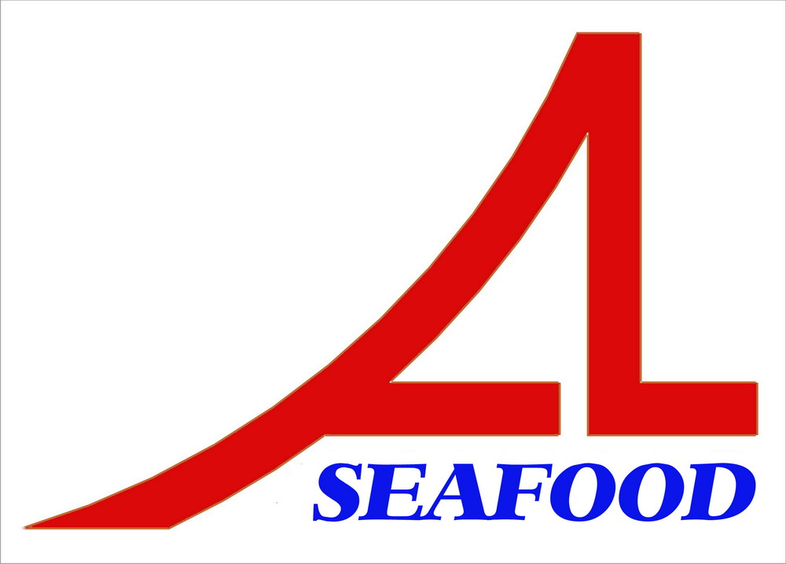AN LAC SEAFOOD CO.,LTD
LOT A14,4A STREET,HAISON INDUSTRIAL ZONE,DUC HOA DISTRICT,LONG AN PROVINCE,VIETNAM

AGREEMENT
Date :
Party A : AN LAC SEAFOOD CO., LTD.

Address: Lot A14, 4A Street, Hai Son Industrial Zone, Duc Hoa District, Long An Province, Vietnam.

Tel/ Fax: 84-72-3850606 / 84-72-3850608
Represented by: Mr. NGUYEN THIEN DUY – Director

Party B: WORLD FOODS CORPORATION LTD

After discussion , it is must be mutually agreed by both parties to sign for agreement as follow :
After comparing , two parties agree with the prepayment : 18.458,84 USD (base on the advice of bank No.: 120719-8 dated : 19/07/2012 ) will be paid to contract No.: 01/AL – WF/12.
The agreement have valid from the date was signed .
The agreement is made into 02 (two) originals in English , each party keeps 01 (one) original with equal value .
PARTY A PARTY B

